Jawad Ahmad (SP23-BDS-022)
Rohan Younas (SP23-BDS-035)
DM Project
Bank Customer Deposit Subscription Prediction

Submitted to: Dr. Mariam Akbar
Dated: 12/04/2025

Project Report: Bank Customer Deposit Subscription Prediction
Introduction
This project aimed to build a predictive model to determine the likelihood of bank customers subscribing to a term deposit. The model utilizes customer data such as demographics, contact information, and financial attributes. By applying machine learning techniques, the project sought to enable the bank to enhance its marketing strategies and improve customer targeting efficiency.
Data Description
The dataset includes various features related to bank customers:
- Demographics: Age, Job, Marital Status, Education.
- Financial: Balance, Housing loan status, Personal loan status.
- Contact Information: Contact type, Last contact month, Last contact day.
- Campaign Data: Number of contacts during the current and previous campaigns, days since last contact, outcome of the previous campaign.
Preprocessing
- Handling Missing Values: Imputed missing values based on the feature type.
- Feature Encoding: Converted categorical variables to numerical using one-hot encoding.
- Feature Scaling: Normalized numerical features to have a mean of zero and a standard deviation of one.

Classifier Implementation
Implemented four different classification algorithms within a machine learning pipeline:
- Decision Tree Classifier
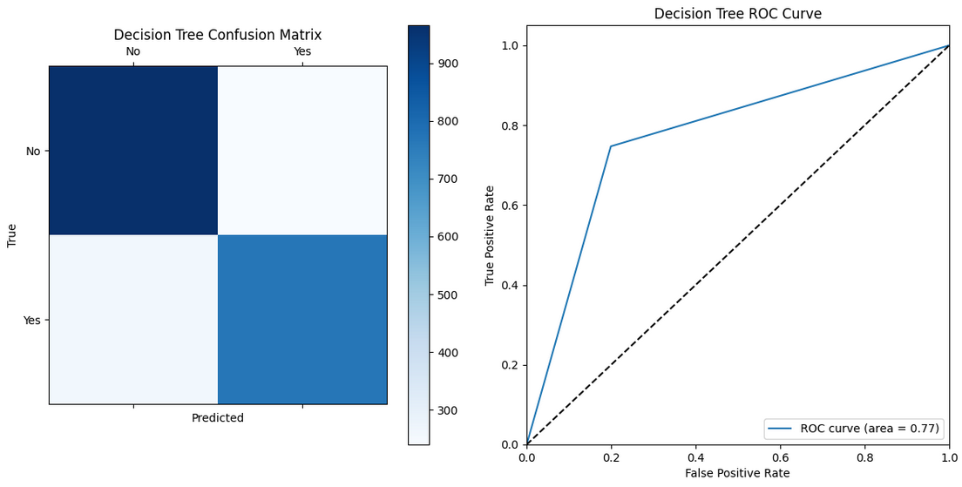
- Support Vector Machine (SVM)
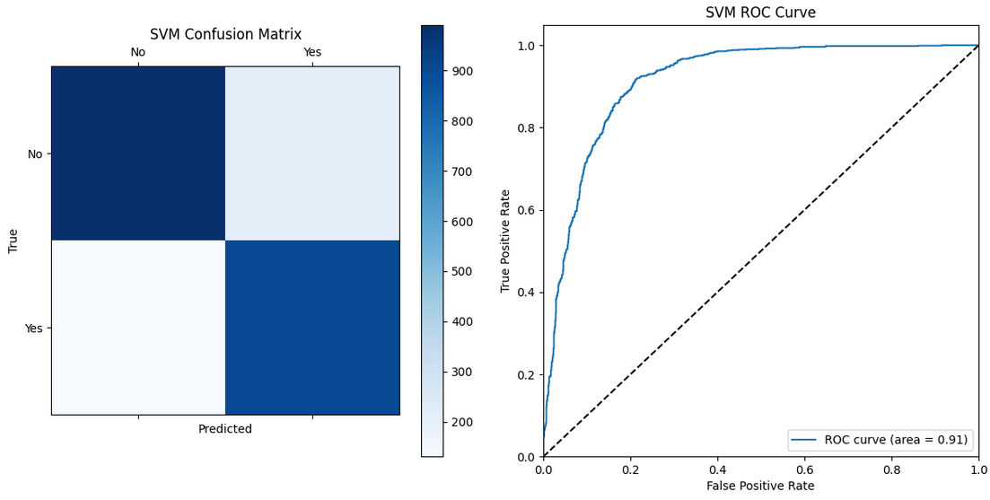

- Random Forest Classifier
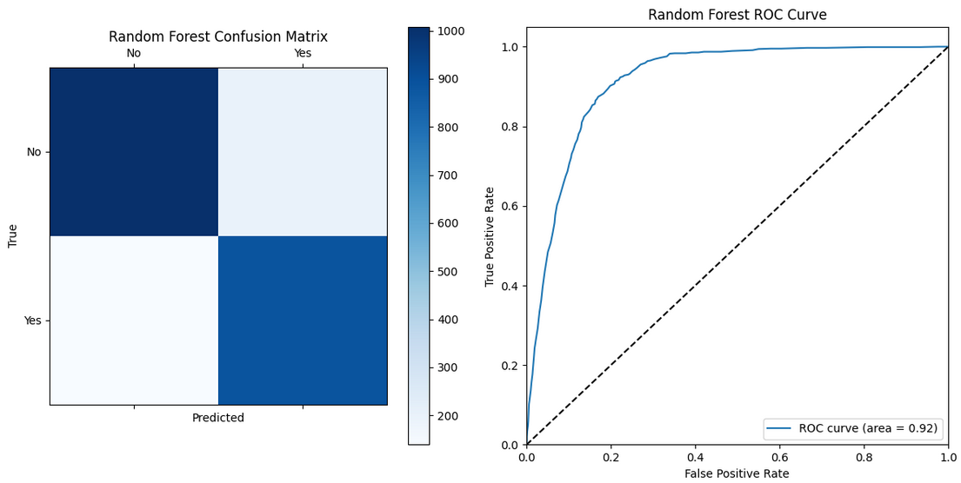
- Logistic Regression
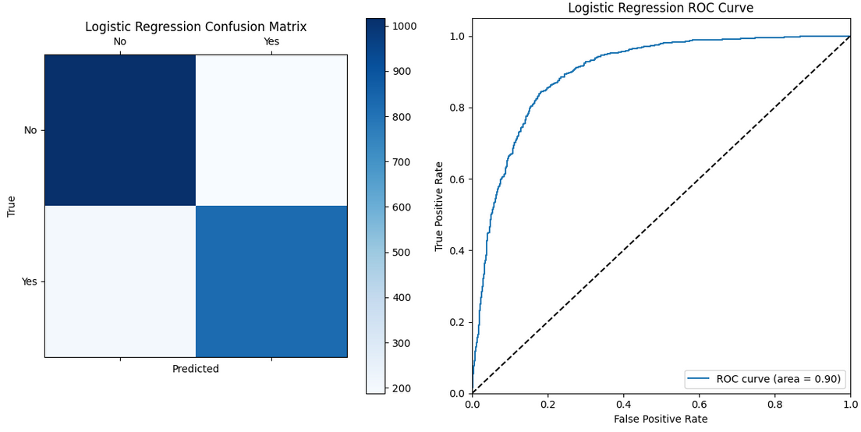

Evaluation Metrics
Models were evaluated based on:
- Accuracy
- Precision
- Recall
- F1 Score
- ROC Curve and AUC
Comparative Analysis
 | Decision Tree Classifier | SVM | Random Forest Classifier | Logistic Regression
Accuracy | 77.60 | 84.55 | 84.95 | 82.53
Precision | 76.19 | 80.73 | 81.86 | 81.46
Recall | 74.71 | 87.26 | 86.48 | 80.35
F1 Score | 75.44 | 83.87 | 84.11 | 80.90
ROC AUC | 77.39 | 91.46 | 91.55 | 81.00

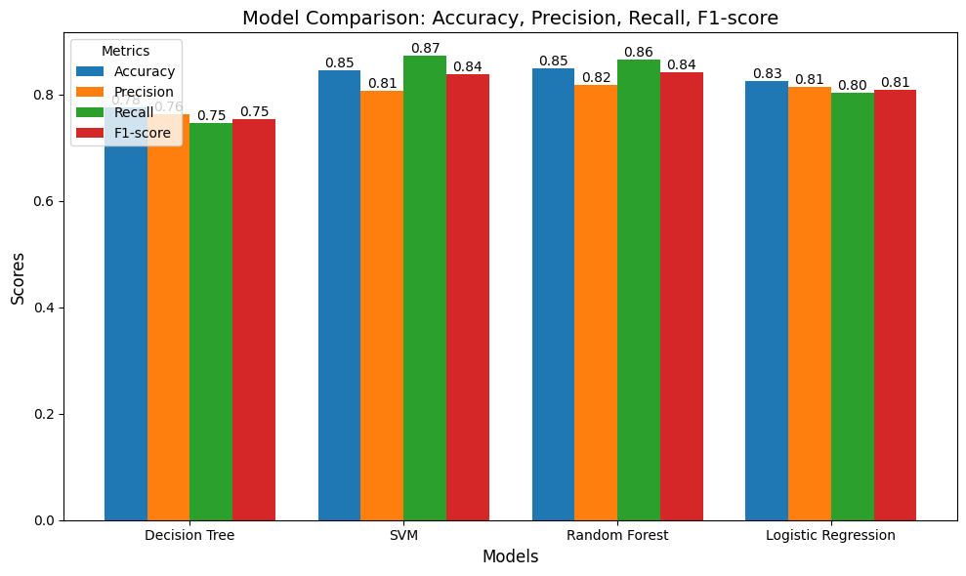

Conclusion
Model Performance
- SVM and Random Forest performed best, with high accuracy and robustness as indicated by their AUC scores.
- Decision Tree showed lower performance, potentially due to overfitting.
- Logistic Regression provided moderate performance.
Important Features
- Duration of the last contact: Most critical predictor of subscription likelihood.
- Balance: Indicates financial health.
- Age: Older customers might have different financial planning needs.
- Outcome Success: Success in previous campaigns significantly influences current decisions.
Impact of Pipelines
- Efficiency: Automation of data preprocessing and model fitting processes.
- Consistency: Ensured consistent application of transformations across different data sets.
- Experimentation: Facilitated easy swapping and testing of various models and preprocessors.
Business Insights and Recommendations
- Targeting Strategy: Focus on clients with successful previous interactions and certain financial standings.
- Resource Allocation: Prioritize marketing efforts on customer segments predicted to have higher subscription likelihood.
- CRM Integration: Use model insights to offer personalized services and promotions.

Conclusion
The predictive modeling project successfully identified key factors influencing bank customers' decisions to subscribe to term deposits. By integrating these insights, the bank can not only refine its marketing approaches but also enhance customer satisfaction through more personalized engagement.

